# **Mid-term Handout**

## **Team 7: EventLAB**

|  |  |  |  |
| --- | --- | --- | --- |
| Name | E-Mail | RUP Roles | Spent Time |
| Anett Richel | anett.richel@web.de | Product Owner, Designer, Configuration Manager | 41h46m |
| Lukas Qualo | lukas@eventlab.jupiterspace.de | Project Manager, Implementer, Test Designer | 42h16m |
| Ben Samtleben | ben.samtleben@gmail.com | Tech Writer, Course Developer, Tester, Scrum Master | 62h48m |

The spent time was measured on 11th December 2018. The current report of our spent time per person and ticket can be found here: *https://eventlab.myjetbrains.com/youtrack/reports/time/128-0*

### **Overall Use Case Diagram**

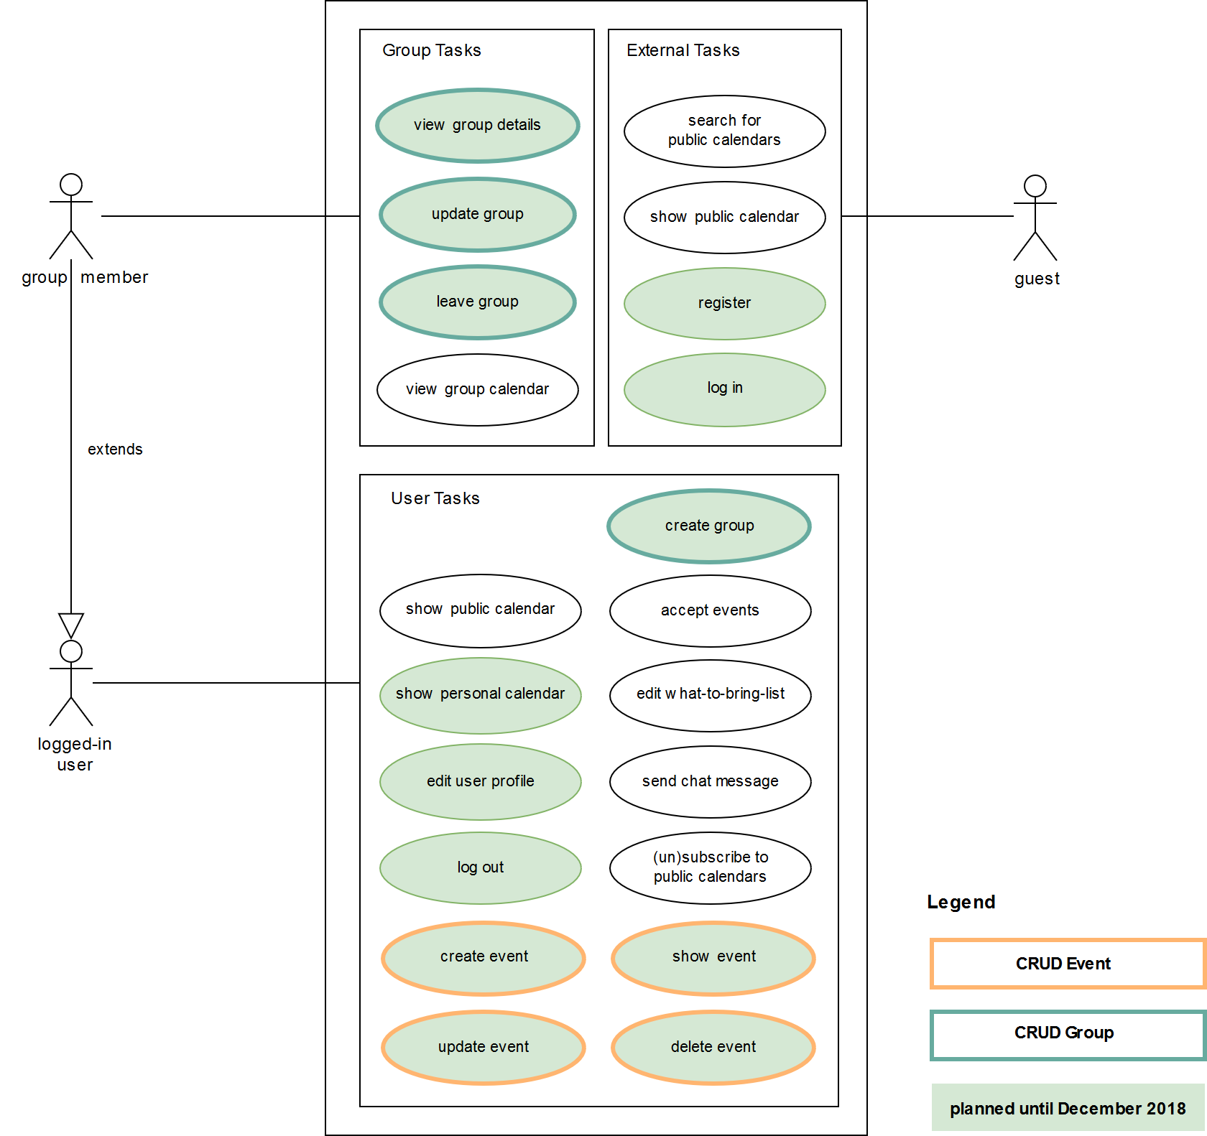

**A collection of some of the most important links regarding our project: https://e-lab.jupiterspace.de**